Master Pop-By Ideas List
LOTS of ideas on Pinterest if you search “realtor pop-by gifts” (you literally could spend hours there, it’s insane)
ALSO, http://www.popbyideas.com/ has TONS of ideas as well.
Great ideas for Wacky Holidays and regular holidays:
http://holidayinsights.com/moreholidays/index.htm
Ideas for warming up agents:
A single tennis shoe, high heel or boot – “Just trying to get my foot in the door. Would love to
meet for coffee.”
A small beach bucket – “I’ve been hearing great things about you. It’s on my bucket list to meet
you. Would love to treat you to coffee.”
Lotto ticket – “I hope this is a lucky day for both of us! I would love to meet you for coffee.”
Small telephone cord – “Trying to find a way to connect. Would love to meet you for coffee.”
Clients or agents you have lost contact with:
Small telephone cord – “So sorry we got disconnected. Expect a call so we can get plugged in
again.”
Random:
-lotto scratchers and payday/100 grand bar (“thanks a million for all you do”)
-popcorn (“just popped by to say hello”)
-starbucks (“Thanks a latte...”
-Burt’s Bees (“Thanks for.... You’re the BALM”)
-mini plant (thanks for helping me grow..)
-flyswatter (“Let our SWAT team of experts help you...”)
-movie candy
-kahlua coffee (“always looking to stir up a few referrals)
-soap (want a “clean” deal?)
-Matches (“other lenders are no match for our level of service...”)
-piggy bank (“our relationship is one of the most valuable assets we have...”)
-cookbook (“let me be part of your ingredients for a perfect closing”)
-pop rocks (“You rock!” or “Let your clients loan experience rock...”)
-calculator (“it's the little things that add up to a successful closing! Let me take care of those for
you and get you to the closing table on time!”)
-screwdriver (“be the sharpest tool in the shed and refer your clients to...”

-highlighters (“working with you is the highlight of our...”)
-candle or lighter (“your referrals really light my business on fire”)
-oven mitt (I have to ad”mitt” it, you’re one awesome partner...)
-animal crackers (“it can be a jungle out there, but I’m here to help your clients get safely
through”)
-book (“I am never too booked for your referrals”)
January:
-soda (“hope you start the new year with a POP”)
Easter:
-peeps (“Have your peeps call my peeps!”)
Mother’s Day:
-Flowers for mom realtors
Summer:
-bbq sauce (“summer is near and BBQ season is here! Enjoy the sun, have some fun, and
remember your referrals are #1!”)
-sunblock (don’t let your friends and family get “burned” in this market, I will give them the
protection they need)
-beach ball (“I’m always on the ball to help your clients)
July:
-fireworks schedule (celebrating your referrals and the 4th of july)
-sparklers (your referrals make my business sparkle)
Father’s Day:
-WD-40
-fuel injector cleaner (your referrals keep my engine running”)
Back to school:
-Pencils- “We’ll erase your worries. Call us for an A+ experience. ”
Halloween:
-caramel apples (“for a transaction that’s always sweet and never sticky”)
-pumpkin carving kit (“im always ready to carve out time to serve you and your referrals”)
-apple crisp mix (“your referrals are the core of my business”)
Thanksgiving:
-pie cutter (“Any way you slice it, I’m grateful for your referrals”)
December:

-gift tags
-wrapping paper
-little bells (“give me a jingle if i can help...”)
-hot cocoa/mug
-martinelli's
-joy soap (“May joy be your gift at Christmas and your blessing all year through...”)
-jolly ranchers (“Have a holly jolly christmas”)
-fortune cookies (“wishing you good fortune in the new year”)
-Peppermints (your help MINT so much to us this year)
Here is the info on the link to what I uploaded to the Freedom Club site: http://www.mortgagemarketinganimals.com/coaching/freedom-club/june-2014-shares/
The Duford Team examples of tag lines we have used
to “drop in” on realtors and clients with a “drop in” goodie.
The “drop in goodie” is for agents who send you referrals. It’s our way of showing them we appreciate them and their referrals.
It can also be used as a possible idea to get the attention of agents you have been calling every Monday with no response
The purpose of “dropping in” to a realtor’s office:
Get to know their front desk “gatekeeper”. This person should become your best friend at that office. Not enough people pay attention to her and get to know or ask about her/him. You will stand out and make her/his day.
ALWAYS bring this person (your friend) a “drop in” goodie and chat for a minute. -She/he knows every agent in the office and will say good things about you. -She can put in a good word for you with the Broker and the Agents
Leave the agent (s) the goodie and then call to check in (gives you a reason) Never end a call without asking for referrals.
Past Clients are the GOLDMINE in your database
Never take your past clients for granted. They will refer you people they know if you ASK them to and keep in touch with them regularly.
The “drop in goodie” is also used to give you a reason to see a client face to face.

You can leave it at their workplace (everyone sees it and wonders why “their” lender doesn’t do
nice things like this)
You can leave it on their doorstep at home if they are not home and then text, call or email to
make sure they received it. The best way is to call because you are letting them know you are thinking of them enough to drop off a little “goodie” to them. Never end a call without asking for
referrals.
You can add a color picture with the tag line (laminated) and a nice picture that goes with it.
Attach your business card to the “drop in goodie (see samples below)
“Drop in” to Agents and Clients - tag lines with ideas from
Kevin at The Duford Team 6-5-14
Pencil : “We’ll erase your worries. Call us for an A+ experience.”
Dog Bones for those who love dogs : “No bones about it, we have your lending needs covered”.
Mini First Aid Kit: “It pays to be prepared for every situation. Let us be the choice to help you
1 ^{st}
avoid all the emergencies that come up! The Duford Team will come to your aid”.
Soap : “Just stopped by to say hello... If you work with someone who is looking to buy a home
and wants a “clean deal” give us a call” OR
“Want a clean deal/transaction?? The Duford Team can get it done “clean and quick.” Blank Note Cards: “We want you to know how much we appreciate you. Thank you for your
business and referrals. Next time you think of someone special use these note cards to let
them know.”
Lighter or matches: “Other lenders are no match for our level of service. We’re fired up to serve
you and your clients!”
Bungee Cords: “We’re here to secure the right loan for you!”
Band-Aids : “Let us help “aid” you to more paychecks! With our quick processing we close your
deals quickly”.
Peanuts: "We are nuts for your referrals"
Spatulas : "We flip for your referrals"

Blocks : The Duford Team would love to help you “build” your business (we used these for
newer agents that were on fire or agents that expressed desire to learn more about our tools)
Piggy Bank : “Our relationship is one of the most valuable assets we have”
Salsa Bowls : “You and your referrals always “spice” up our day”
Fortune cookies : “It is our good fortune to serve you and everyone you refer”
Oven mitts : "We’re ready to take care of your hot referrals"
Orange : “Can’t make “heads or tails” of today’s Real Estate market? “Orange” you glad you can depend on us to take care of you?
Microwave Popcorn: “Just wanted to “pop” by to tell you that we appreciate you as clients. If you know anyone looking to buy or refinance, hopefully we “pop” up. Just give them our name and number.
Electronic disposable wipes:
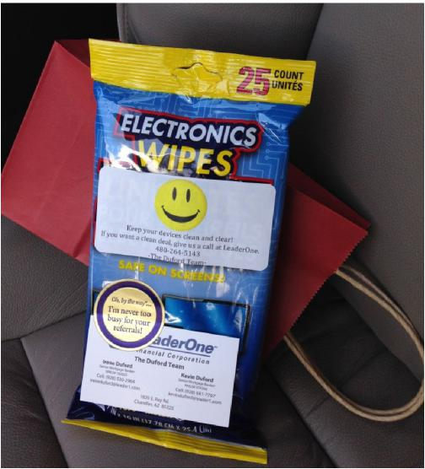
Holiday themes to create a “drop in” for:
January:
New Years Day

Martin Luther King Day
February:
Groundhog Day
Valentine’s Day
March:
St. Patrick’s Day
Daylight Savings Day begins
First Day of Spring
April:
Easter:
Peeps marshmallow treats : “Have your peeps call my peeps”
May:
Mother’s Day:
Flowers: Kevin Hand Delivers flowers to agents who are Moms and to Escrow Officers too.
(This by far leaves the biggest impact of all we do all year)
Memorial Day
June:
Flag Day
Father’s Day: BBQ sauce or “spatula”
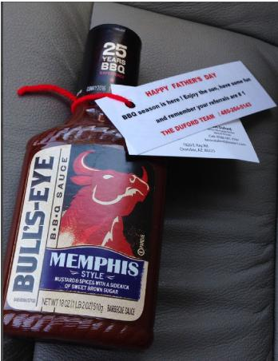

First Day of Summer: “Summer is near and BBQ season is here! Enjoy the sun, have some fun and remember your referrals are #1!” (BBQ Sauce)
July:
Independence Day
August:
First Day of School
Peach Month and Picnic Month
September:
Labor Day
Grandparent’s Day
First Day of Autumn
October:
Columbus Day
United Nations Day
Halloween:
Halloween Bat Glasses : “Are other lenders driving you batty? Let the Duford Team help you
see the way to more closed deals”.
Halloween Bat Straws : “Are other lenders driving you batty? Let the Duford Team help you drink from the cup of success”.
November:
Daylight Savings Time ends
Veteran’s Day
Thanksgiving time:
Fresh Pies -Talk about gratitude for them (Helps clients and b2b bakery)
Calendars with your info (helpful to have holidays and days that won't count for work days or recision and early off times
Ziploc Bags : “The holidays are headed your way! This means special times with family, friends and good food. These will help “seal” your favorite leftovers and keep them fresh. And when the conversation turns to home loans... remember we’re here to help “SEAL” the deal!”
December:

Hannukah
First Day of Winter
Christmas
New Year’s Eve
Gift wrapping supplies-wrapping paper, gift bags, tape, bows, gift tags
Fresh baked cookies, brownies, or bread
Tree ornament, or other holiday decoration
Box of blank holiday cards: "Tis' the season to be grateful for great clients like you"
Hot Chocolate: “The chill of winter is warmed by clients like you”
Only to agents we know real well and wanted to have a laugh with them:
(This may not be for everyone but Kevin used it with a few of our agents he can laugh with.
They got a kick out of it.)
Straws : “Some lenders really suck! We do what we say we can do. That allows you to enjoy a drink from the fountain of success”.
Small Screwdriver : “Don’t get screwed by lenders who can’t deliver. Call The Duford Team to get the deal done right”.
Great pop-by ideas from a real estate agent:
http://www.popbyideas.com/
Great ideas for Wacky Holidays on this site:
http://holidayinsights.com/moreholidays/index.htm
Ideas for warming up agents:
A single tennis shoe, high heel or boot – “Just trying to get my foot in the door. Would love to
meet for coffee.”
A small beach bucket – “I’ve been hearing great things about you. It’s on my bucket list to meet you. Would love to treat you to coffee.”
Lotto ticket – “I hope this is a lucky day for both of us! I would love to meet you for coffee.” Small telephone cord – “Trying to find a way to connect. Would love to meet you for coffee.” Clients or agents you have lost contact with:

Small telephone cord – “So sorry we got disconnected. Expect a call so we can get plugged in again.”

